05-2026
Final simulations - Updated with new param, 40% constant CM from 2000 – 2031, 50k popsize
Used EIR: seq (1, 20, 0.5), 24, 32, 48, 60, 80, 100
All ages
- $Low {PfPR}_{0-100}=\left[0.009 - 0.1\right]-EIR≤2$
- $Moderate {PfPR}_{0-100}=\left[0.13 - 0.34\right]-2<EIR≤8$
- $High {PfPR}_{0-100}=\left[0.36 - 0.46\right]-8<EIR≤100$
LOW: 1.0, 1.5, 2.0 – (3)

MODERATE: 2.5, 3.0, 3.5, 4.0, 4.5, 5.0, 5.5, 6.0, 6.5, 7.0, 7.5, 8.0 – (12)

HIGH: 8.5, 9.0, 9.5, 10.0, 10.5, 11.0, 11.5, 12.0, 12.5, 13.0, 13.5, 14.0, 14.5, 15.0, 15.5, 16.0, 16.5, 17.0, 17.5, 18.0, 18.5, 19.0, 19.5, 20.0, 24.0, 32.0, 48.0, 60.0, 80.0, 100.0 – (30)

- Averaged EIRs for low, moderate, and high
- Analysis of net impact averaged over all 3 campaigns
- Pre-intervention PfPR temporal trends = 2022 PfPR (just before nets)
- Baseline pfpr for subsequent plots = malaria prevalence among non-users when no one uses nets (0% coverage)

Temporal trends
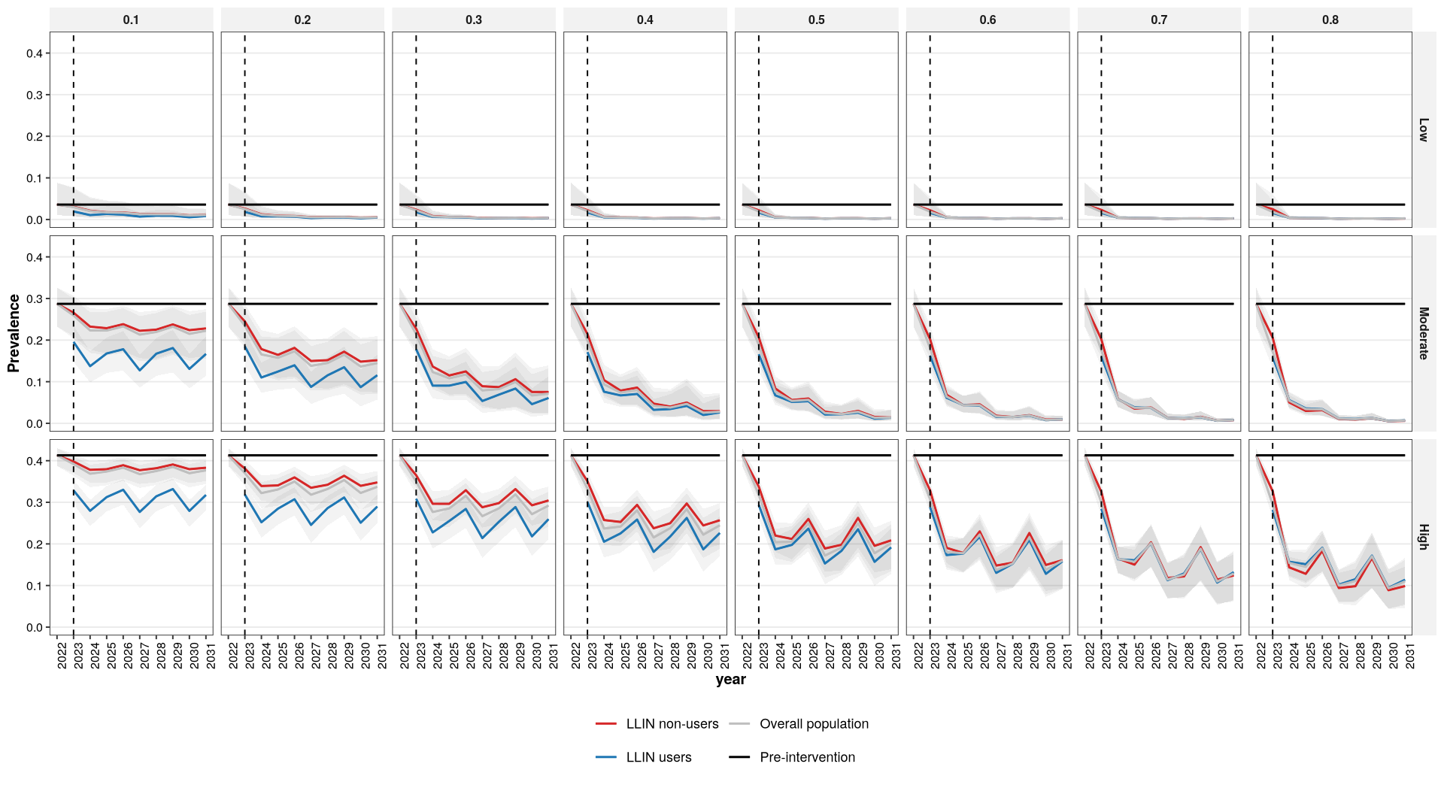

Fig 1 – community protection is constant over time, but varies with increasing usage and transmission intensity
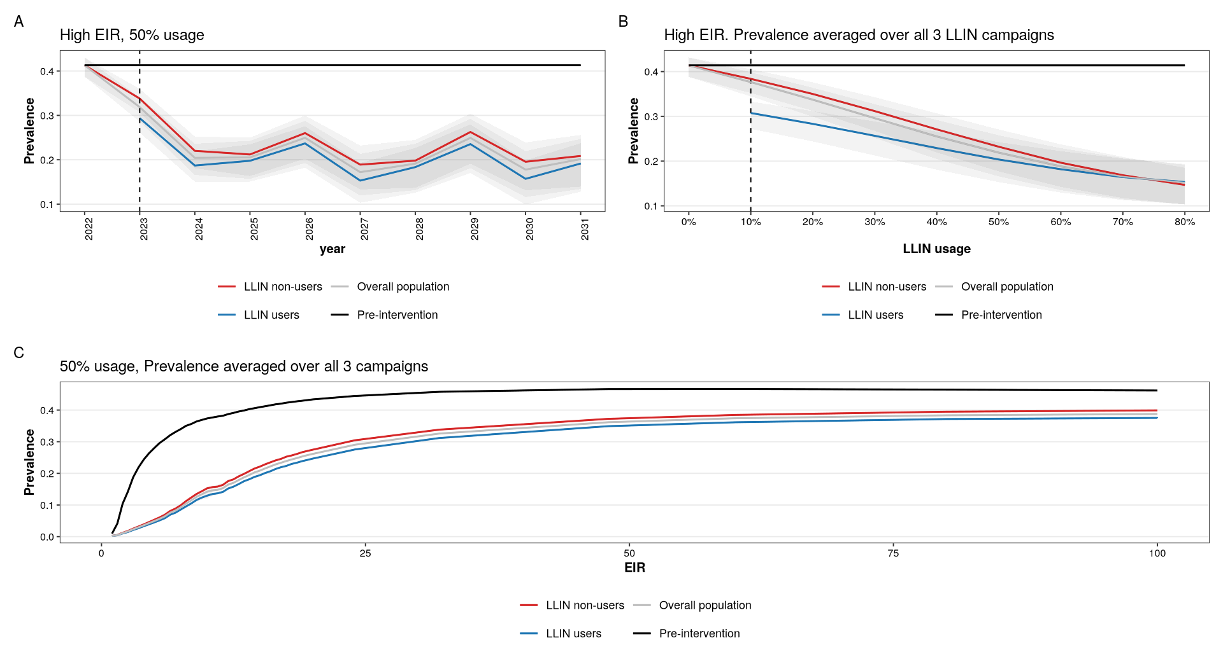

Severe and uncomplicated cases plot – with increasing LLIN usage, we observe a decline in prevalence, uncomplicated and severe cases among LLIN non-users due to community protection
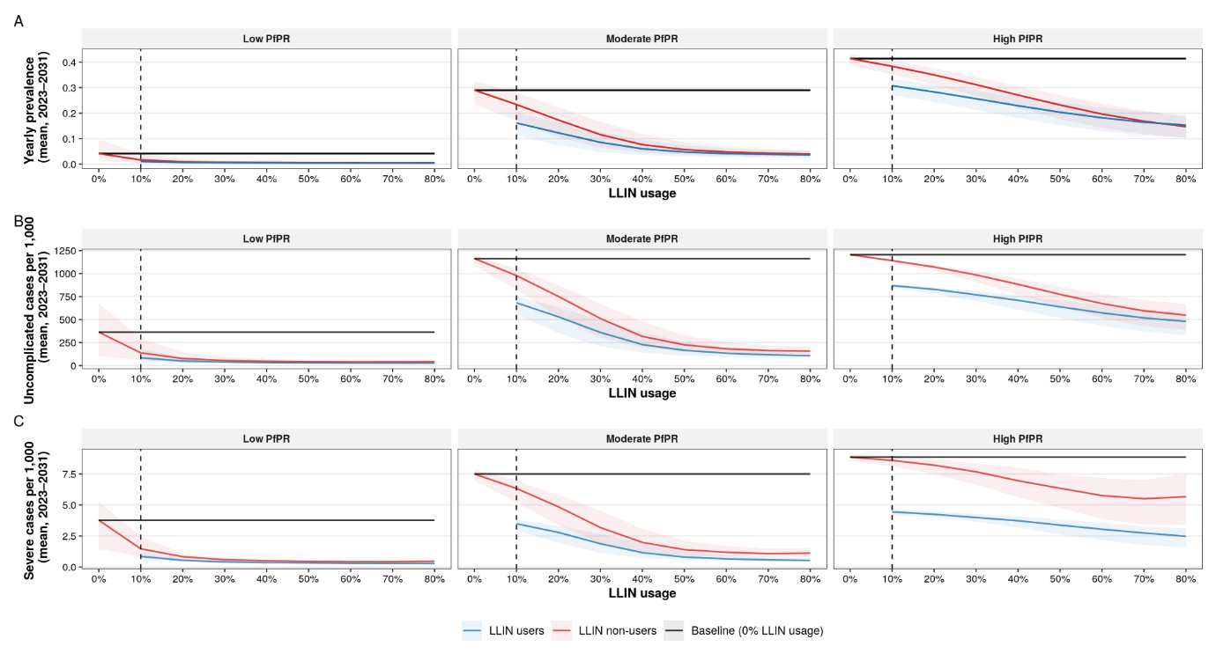

Fig 2 – : community effect plateaus in low and moderate, but not in high transmission intensity
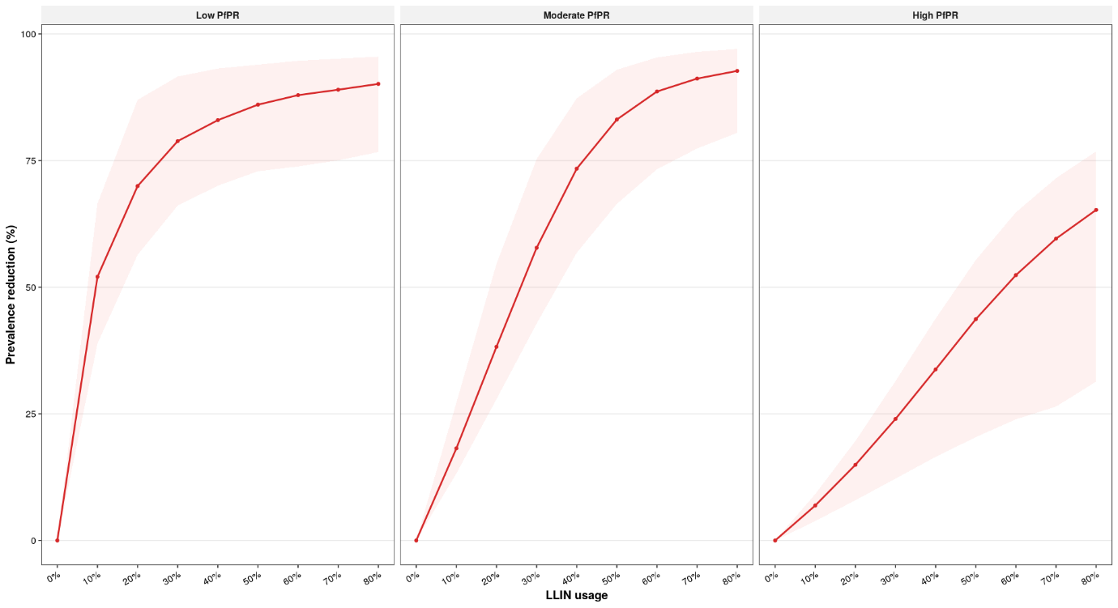

Fig 3 - Non-users protected and non-users protected per additional LLIN user
Calculate the metric: $\text{Non-users protected per user}$
At a given usage level,
- $\text{number of users}\text{ = usage x population size}$
- $\text{users protected}\text{ from infection} \text{= }\text{prevalence reduction}\text{ x }\text{number of }\text{users}$
- $\text{remaining non-users}\text{ = (1-usage) x population size}$
- $\text{additional users}\text{ = change in usage x population size}$
- $\text{non-users protected} \text{from infection} \text{= }\text{prevalence reduction}\text{ x }\text{remaining non-users}$
- $\text{non-users protected} \text{from infection}\text{ per }\text{LLIN}\text{ user}$ = $\frac{\text{non-users protected}\text{ (compared to baseline)}}{\text{number of users (compared to baseline)}}$
- $\text{Non-users protected per}\text{ additional}\text{ user}\text{= }\frac{\text{non-users protected}\text{ (incremental)}}{\text{additional users}\text{ (incremental)} }$

A: total users protected compared with 0% usage.
B: total non-users protected compared with 0% usage.
C: non-users protected per LLIN user compared with 0% usage.
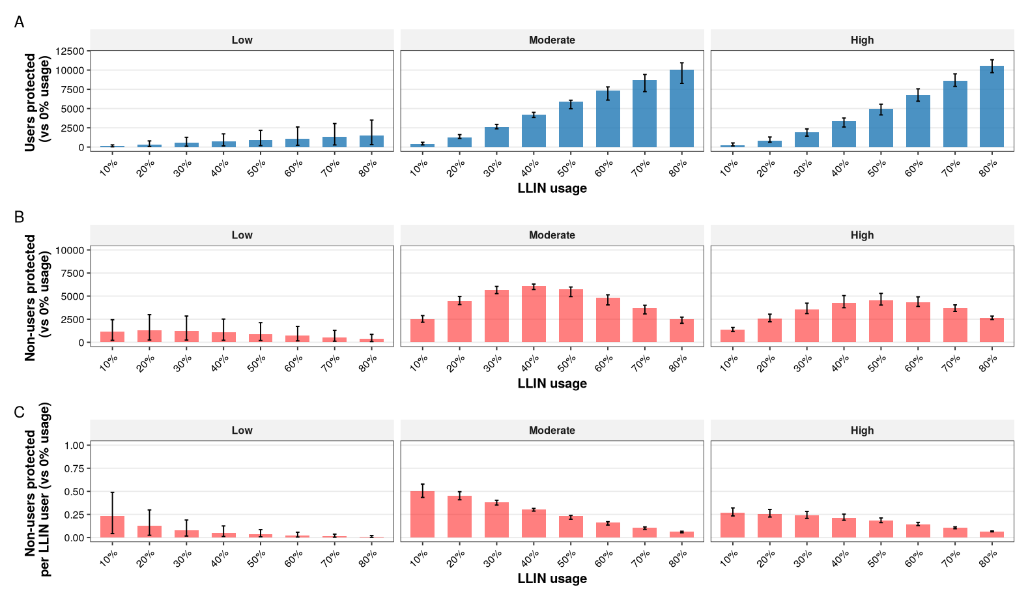

Fig 4 - Cost Effectiveness Analysis
Unit cost is the cost per unit (per ITN delivered) at a given coverage level (Q)
$UC(Q)=C_{fix}+\left(\frac{L_{fix}}{Q} + L_{var} + s*max{(0,c-c_{0}​)}^{2}\right)$, where $c_{0}​$ is the desired turning point
- $C_{fix}$: unit cost of purchasing a net – $1.5
- $L_{fix}$: fixed logistics cost – [eg. warehouse, vehicles, admin] – $5,000
- $L_{var}$: variable logistics cost - [eg. fuel, personnel per delivery] – $1
- $s$: increasing cost at high coverage to reach the last mile – 30, $c_{0}=0.65$
Parameters were chosen to reflect the mean financial cost per ITN distributed, as in Wiesniewski et al., 2020 - $3.52

3 cost structures:
Constant – scale with $Q_{ref}=ref_{cov}*pop$ , is 10% cov – indicating the starting point of all cost structures
$UC\left(Q\right)=C_{fix}+(\frac{L_{fix}}{Q_{ref}}+L_{var})$ = $3.5 per net delivered
Economies of scale – low cost as coverage increases
$UC\left(Q\right)=C_{fix}+(\frac{L_{fix}}{Q}+L_{var})$ = $3.5 – $ per net delivered
U-shaped cost – includes the cost of reaching the last mile
$UC(Q)=C_{fix}+\left(\frac{L_{fix}}{Q} + L_{var} + s*max{(0,c-c_{0}​)}^{2}\right)$ = $3.5 - $ - $ per net delivered
Total cost, $TC\left(Q\right)=UC\left(Q\right)*Q$
- $Q*C_{fix}$: total cost of purchasing nets
- $L_{fix}$: warehouse, vehicles, admin (same cost independent of coverage)
- $Q*L_{var}$: fuel, personnel per delivery (dependent on coverage)
- $s*max{\left(0,c-c_{0}​\right)}^{2}*Q$: threshold last mile term - increasing cost at high coverage to reach the last mile

$$\text{non-users protected}\text{ from infection}\text{ per dollar}\text{ spent}=\frac{\text{non-users protected}\text{ from infection} (Q)}{TC(Q)}$$

Users and Non-users protected from infection per dollar spent

- Loss of immunity after intervention – see a rebound
- Consensus for literature search

